**Topic: Convolution Neural Network (CNN)**

**Instructions:**

**1. Business Problem**

* 1. **Objective**
  2. **Constraints (if any)**

**Using Python perform:**

**2. Data Pre-processing (if applicable)**

**2.1 Data cleaning, Feature Engineering etc.**

**3. Exploratory Data Analysis (EDA): (if applicable)**

**3.1. Summary**

**3.2. Univariate analysis**

**3.3. Bivariate analysis**

**4. Model Building**

**4.3 Using Python libraries perform the below tasks**

**5. Result Share the benefits/impact of the solution - how or in what way the business (client) gets benefit from the solution provided. (If applicable)**

**Note:**

The assignment should be submitted in the following format:

* Python code
* Code Modularization should be maintained
* Documentation of the modules (elaborating on steps mentioned above).

1. **Build a CNN model on CIFAR-10 dataset by applying few regularization techniques like drop out and data augmentation**

**Ans:**

* The dataset is comprised of 60,000 32×32-pixel color photographs of objects from 10 classes, such as frogs, birds, cats, ships, etc.
* By the taking the input of a image as 64x64x3 and convolution by 10 5x5 filters the model is built.

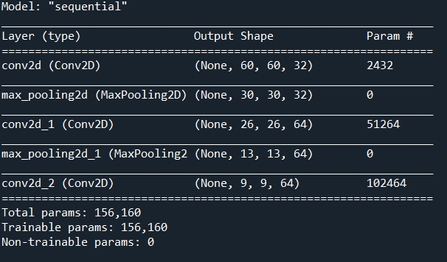

* From the above the total formed parameters are 1,56,160
* Now the model is flattened by using “relu” and “SoftMax” function and checking for the parameters.

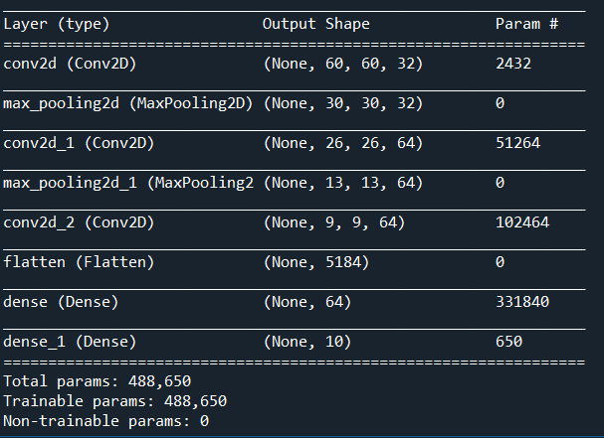

* From the above the total formed parameters are 4,88,650

**Model Building:**

* Now using the keras the dataset of cifar10 is imported
* As we know that there are 10 classes and that classes are represented as unique integers.
* using  [one hot encoding](https://machinelearningmastery.com/why-one-hot-encode-data-in-machine-learning/) for the class element of each sample, transforming the integer into a 10 element binary vector with a 1 for the index of the class value. We can achieve this with the *to_categorical()* utility function.
* We can see that there are 50,000 examples in the training dataset and 10,000 in the test dataset and that images are indeed square with 32×32 pixels and color, with three channels
* the pixel values for each image in the dataset are unsigned integers in the range between no color and full color, or 0 and 255.
* Fitting the model will require that the number of training epochs and batch size to be specified. We will use a generic 15 training epochs for now and a modest batch size of 64 with accuracy 89% at epoch 15.
* The results of the model on the test dataset showed an improvement in classification accuracy with each increase in the depth of the model.

2. **Find out the differences between Convnet filter and the Maxpool layers**

**Ans:**

There is no learning done in max pooling layers, no weights or parameters to update just down sampling. However, in convolutional layers there are weights that are learned so it down samples the data (if no padding is used) but it also extracts learned features.

Usually both are used. A conv layer to extract features and a max pool to down sample and reduce the size of data.

3) **If the input of an image is 64x64x3 which has been convolved by 10 5x5 filters with stride 1 and padding 2.**

1. **How many activation maps are obtained?**

**Ans: 10**

1. **What is the size of the activation maps?**

**Ans: 64x64x10**

1. **How many parameters are calculated?**

**Ans: 760**

**4) During training, I get into overfitting issues. What are the different techniques will you apply to overcome this issue and why?**

**Ans:**

Overfitting happens when your model fits too well to the training set. It then becomes difficult for the model to generalize to new examples that were not in the training set.

**Different Techniques:**

* Add More data
* Data augmentation
* Use architectures that generalize well. However, the most important is the next step of regularization.
* Add regularization like L1/L2 regularization can be applied
* Reduce architecture complexity.